Multi-Sensor Approach for Debris Cover Mapping Over Himalayan Glaciers

Submitted in partial fulfillment for the course credit
Geo-informatics and Natural Resources Engineering
By
Salah Ud Din, Punit Kumar, Krish Bansal
Under supervision
of
Prof. Gulab Singh



Centre of Studies in Resources Engineering
INDIAN INSTITUTE OF TECHNOLOGY BOMBAY
November 2025

Abstract
The study aims to map and quantify the debris cover extent of the Drang Drung and Pensilungpa glaciers in the Ladakh Himalaya using a multi-sensor approach integrating Sentinel-1A Synthetic Aperture Radar (C-band) and Landsat-8 optical imagery. Sentinel-1A co-polarization, VH backscatter data were analysed to assess surface roughness and dielectric variations, while optical spectral bands (7-6-2) from Landsat-8 were used to identify visual contrasts between ice and debris surfaces. Training samples were generated from optical imagery in QGIS and integrated with radar backscatter features in a Random Forest model, enabling separation of glacier surfaces based on their physical and textural characteristics. The results revealed that Drang Drung Glacier exhibits a thin and patchy debris cover, promoting faster melting, whereas the Pensilungpa Glacier shows a thicker debris that acts as an insulating layer, reducing melt in some regions but enhancing localized melting through thermokarst development. The results indicate that the Drang Drung Glacier exhibits a debris-covered area of approximately 22.32 km² (27.3%) out of a total glacier extent of 80.24 km², while the Pensilungpa Glacier shows 6.09 km² (36%) debris cover out of 16.89 km². Debris concentration is higher near the lower ablation zones and lateral moraines, reflecting enhanced surface melting and sediment accumulation. The classification achieved an overall accuracy exceeding 89%, demonstrating the efficiency of integrating SAR and optical datasets for detailed debris cover mapping in high-altitude Himalayan environments.
Keywords: Sentinel-1, Landsat-8, Debris Cover, Machine Learning, SAR Polarimetry,

Table of content
Abstract - 1 -
Chapter: 1 Introduction - 3 -
1.1 Background and Motivation - 3 -
1.2 Problem Statement - 4 -
1.3 Research Objectives - 4 -
Chapter: 3 Methodology - 6 -
3.1 Study Area - 6 -
3.1.1 Drang Drung Glacier - 6 -
3.1.2 Pensilungpa Glacier - 7 -
3.2 Detail workplan and methodology - 8 -
3.3.3 Result and conclusion of 2020 - 15 -
References - 17 -

Chapter: 1 Introduction

1.1 Background and Motivation
High-mountain Asia is experiencing rapid cryospheric change that threatens downstream water security, hydropower reliability, and hazard exposure from glacial lake outburst floods. Precision glacier monitoring—using modern geospatial technology to make mapping more accurate and controlled—has emerged as a critical response. Satellite remote sensing provides comprehensive, regular coverage of glacierized terrain, enabling non-invasive assessment of extent, debris cover, surface condition, and seasonal dynamics at scale. However, translating raw SAR and optical imagery into actionable glacier information still demands significant domain expertise and manual processing. Traditional cryosphere workflows involve manual scene discovery and download, followed by expert-driven preprocessing and analysis steps. The process is time-intensive and typically requires sequential, human-in-the-loop decisions at multiple stages. These bottlenecks limit both the scalability and responsiveness of glacier monitoring solutions. Advancing software-driven automation and interoperable geospatial services creates an opportunity to streamline these pipelines, enabling intuitive interaction with complex satellite analysis chains without requiring specialized technical knowledge from end users.

1.2 Problem Statement
The accurate identification and mapping of debris-covered glacier surfaces remain one of the most challenging tasks in Himalayan glaciology. In high-altitude regions such as Ladakh, glaciers are often partially or completely covered by a thick layer of rock debris derived from surrounding valley walls through frost weathering, avalanching, and rockfalls. This debris mantle significantly alters the glacier’s surface energy balance, reducing reflectivity (albedo) and modifying melt dynamics. Thick debris insulates the underlying ice and reduces melting, while thin debris enhances melt due to increased absorption of solar radiation. Consequently, precise mapping of debris distribution is critical for understanding glacier mass balance, meltwater runoff, and hydrological contributions to downstream river systems like the Zanskar and Indus.
However, traditional optical remote sensing methods face major limitations in mapping debris-covered glaciers. Debris-covered ice and adjacent moraines exhibit similar spectral reflectance, especially in visible and near-infrared wavelengths, making them difficult to differentiate using optical data alone. Additionally, frequent cloud cover, terrain shadows, and illumination differences in rugged Himalayan topography cause further spectral ambiguity. The lack of consistent field observations and long-term ground measurements in Ladakh exacerbates this problem, hindering validation of satellite-derived products.
To address these challenges, this study integrates Sentinel-1A Synthetic Aperture Radar (SAR) and Landsat-9 multispectral imagery within a Random Forest classification framework to accurately delineate debris-covered and clean ice zones over the Drang Drung and Pensilungpa glaciers. By combining radar backscatter (sensitive to surface roughness and moisture) with optical reflectance data (sensitive to color and composition), this approach overcomes the spectral limitations of conventional methods. The outcome aims to establish a robust, multi-sensor methodology for continuous monitoring of debris cover evolution in the climatically fragile Ladakh Himalaya.

1.3 Research Objectives
This project aims to develop an autonomous software framework that addresses the identified limitations through several key capabilities. The primary objective is to enable rule-driven task decomposition, wherein glacier-monitoring requests are automatically translated into executable workflow graphs with explicit dependencies. The framework must support unattended execution via coordinating services that manage satellite data access, preprocessing, feature generation, and validation, with built-in error recovery at each step. Robust state management is essential, requiring persistent and serializable structures that enable recovery from failures, comprehensive auditing of system behavior, and reproducibility of analytical runs. The system should provide a clear, form- and map-based interface that exposes satellite-powered cryosphere analysis without forcing users to handle complex technical details. Finally, geospatial visualization capabilities are needed to deliver near-real-time outputs such as debris maps, threshold-based indices, confidence layers, and change detection on interactive web maps, allowing users to quickly interpret and act upon the generated insights across seasons and basins.

Chapter: 2 Methodology

2.1 Study Area
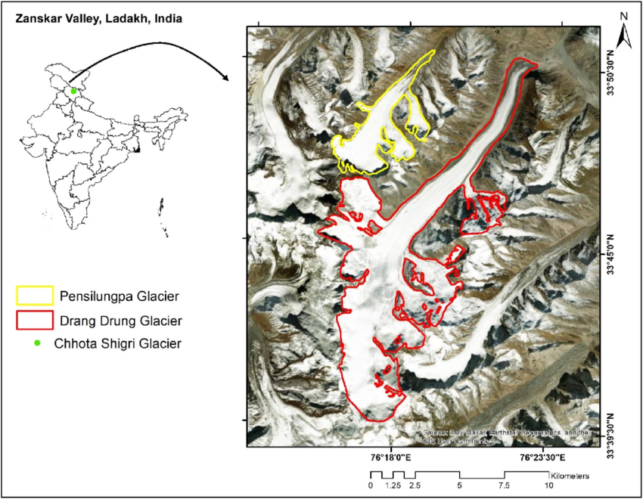
Figure 1 STUDY AREA

2.1.1 Drang Drung Glacier
The Drang Drung Glacier, situated near Pensi La Pass (33.9°N, 76.5°E) in the Zanskar region of Ladakh, India, is one of the largest valley glaciers in the Greater Himalayan Range. Extending approximately 20-23 km in length, it originates from the Doda Peak at an elevation of around 5,400 m and flows eastward to form the headwaters of the Stod River, a major tributary of the Zanskar. The glacier exhibits distinct geomorphological zones an accumulation zone of clean ice in the upper reaches and a broad ablation zone covered by rock debris in its lower part. This debris layer significantly influences the melting rate and mass balance of the glacier, making it an ideal site for remote sensing–based debris mapping.
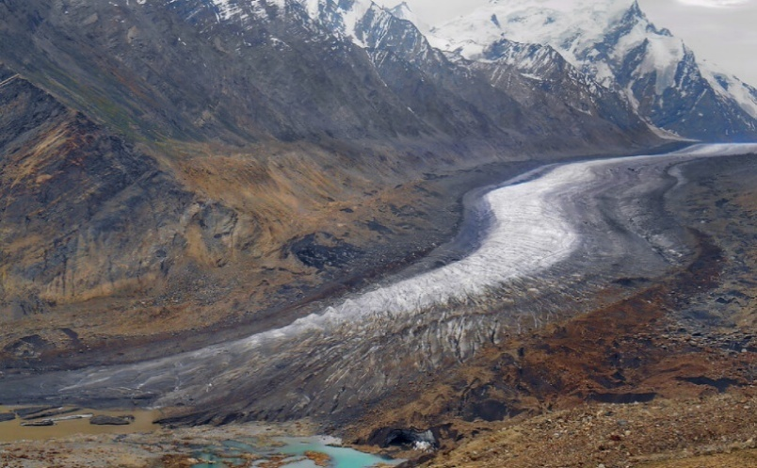
Figure 2 DRANG DRUNG GLACIER

2.1.2 Pensilungpa Glacier
The Pensilungpa Glacier lies close to Drang Drung in the same Zanskar Valley, extending approximately 8 km from its accumulation zone at 5,700 m to its terminus near 4,500 m elevation. The glacier flows eastward and feeds into the Suru River system. It is characterized by rugged surface features, including ice cliffs, supraglacial ponds, and thick debris layers concentrated along its tongue. Recent studies have shown considerable retreat and surface lowering, indicating its high sensitivity to climatic variations. The smaller size and high degree of debris cover make Pensilungpa an important glacier for analysing debris distribution patterns using both radar and optical satellite data.
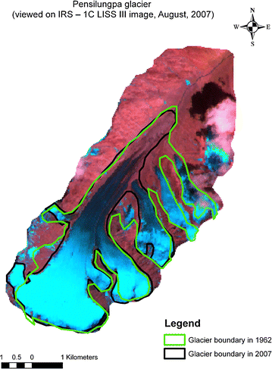
Figure 3 PENSILUNGPA GLACIER

2.2 Detail workplan and methodology
The complete methodology adopted for this study is shown in figure 12, representing the stepwise process from data acquisition to classification and analysis.
SATELLITE DATA
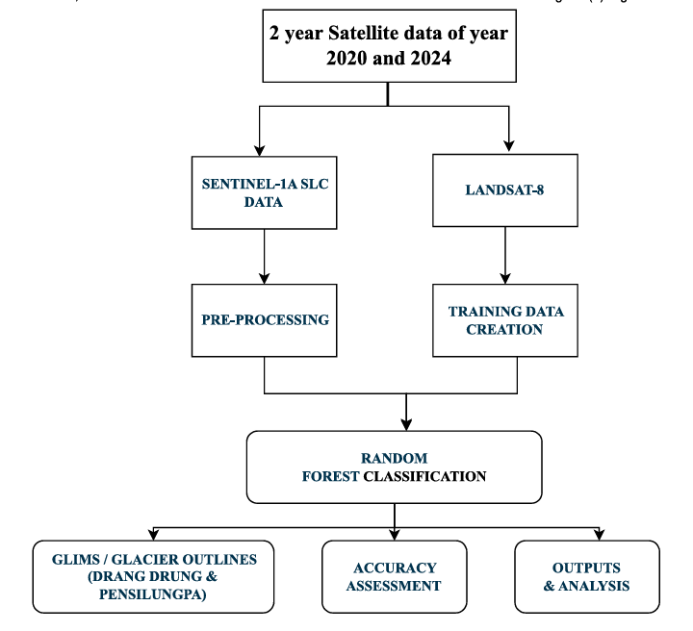
Figure 4 Methodology flow diagram
1. Satellite Data Acquisition
Satellites are artificial objects placed in orbit around the Earth to collect data about the planet’s surface, atmosphere, and oceans. They play an indispensable role in Earth observation by providing repetitive, large-scale, and accurate information over inaccessible regions such as the Ladakh Himalaya. Satellite sensors operate primarily in two modes: passive sensors, which detect naturally reflected or emitted energy (like those on Landsat satellites), and active sensors, which emit their own signals and record the reflected energy (as in radar systems like Sentinel-1A). These complementary sensing mechanisms enable the continuous monitoring of dynamic landforms such as glaciers, which are difficult to observe through ground-based methods due to harsh environmental conditions.
For this study, multi-sensor datasets were used to capture both spectral and structural characteristics of glacier surfaces.
- Sentinel-1A Synthetic Aperture Radar (SAR) data were obtained from the Alaska Satellite Facility (ASF DAAC). Sentinel-1A operates in the C-band (5.405 GHz) and provides VV and VH polarizations, enabling detailed assessment of surface roughness, dielectric properties, and moisture content. SAR data have the unique advantage of penetrating cloud cover and acquiring information under all-weather and day-night conditions, making them ideal for Himalayan glacier monitoring.
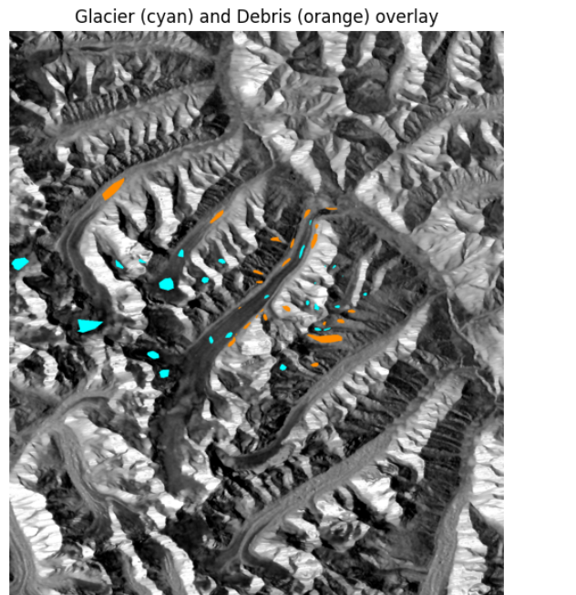
Figure 5 Sentinel 1A SLC image of both the glacier
- Landsat-8 multispectral imagery, acquired from the USGS Earth Explorer and ESA Earth Observation portals, was used for optical feature extraction. Specifically, bands 6 (SWIR1, 1.57–1.65 µm), 7 (SWIR2, 2.11–2.29 µm), and 2 (Blue, 0.45–0.51 µm) were selected for their strong spectral response in distinguishing clean ice, snow, and debris-covered surfaces. Band 2 highlights bright snow and clean ice, while the SWIR bands (6 and 7) effectively detect darker debris and rocky surfaces due to differences in surface reflectance and moisture absorption.
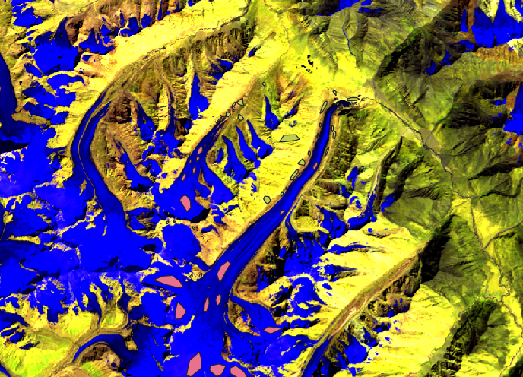
Figure 6 LANDSAT 9
2. Sentinel-1A SAR Data Preprocessing
Preprocessing was performed using the ESA SNAP toolbox following standard procedures to correct for geometric and radiometric distortions:
Preprocessing of Sentinel-1A Synthetic Aperture Radar (SAR) data is a critical step to ensure geometric accuracy, radiometric consistency, and the removal of radar-specific distortions before further analysis. Sentinel-1A operates in Interferometric Wide (IW) swath mode, which captures data across three sub-swaths (IW1, IW2, IW3) using the TOPSAR acquisition technique. Each sub-swath consists of multiple bursts, which must be processed sequentially to form a continuous, georeferenced radar image suitable for polarimetric and classification analysis. All preprocessing operations were performed using the ESA SNAP (Sentinel Application Platform) toolbox.
The preprocessing workflow involved the following steps:
- Splitting by Sub-swaths (IW1, IW2, IW3): Sentinel-1A Level-1 SLC data were divided into individual sub-swaths to process each acquisition segment independently. This step prevents overlap errors and ensures accurate handling of Interferometric Wide swath data.
- Applying Precise Orbit File: Updated orbit ephemerides provided by ESA were applied to correct the satellite’s position and velocity information. This correction improves geometric fidelity and ensures that all subsequent processing aligns accurately with geographic coordinates.
- Radiometric Calibration (Complex Output): Radiometric calibration converts raw radar digital numbers (DN) into physically meaningful backscatter coefficients (σ⁰) while retaining phase information. This step standardizes pixel intensity values and allows for quantitative comparison between scenes and polarization channels.
- TOPSAR Debursting: Since Sentinel-1A acquires data in bursts, the debursting step merges these bursts to create a seamless image within each sub-swath, eliminating discontinuities at burst boundaries.
- Merging Sub-swaths (TOP Merge): All three sub-swaths (IW1, IW2, IW3) were merged to produce a single, continuous radar scene covering the entire glacier region.
- Multilooking: Multilooking was applied to reduce image speckle and improve radiometric quality by averaging neighbouring pixels in range and azimuth directions. This enhances interpretability while maintaining sufficient spatial detail for glacier analysis.
- Polarimetric Speckle Filtering: To further suppress granular noise while preserving polarimetric properties, the Improved Lee Sigma filter was applied. This adaptive filter effectively smooths homogeneous areas and preserves edges and scattering information crucial for distinguishing debris-covered ice from clean ice.
- Terrain Correction (Range-Doppler Geocoding): The Copernicus 30 m Digital Elevation Model (DEM) was used for geometric terrain correction. This step compensates for distortions caused by topography and radar viewing geometry, converting radar coordinates into a georeferenced projection (WGS-84/UTM Zone 43N). The correction ensures accurate spatial alignment between SAR and optical data.
- Polarimetric Matrix (C2 Generation): Dual-polarized Sentinel-1A data (VV and VH) were used to generate the 2×2 covariance matrix (C2), representing the scattering characteristics of each pixel. This matrix is the basis for computing polarimetric parameters such as Entropy (H), Anisotropy (A), and Alpha angle (α), which are later used in debris–ice classification.
3. Feature Extraction
For both datasets, relevant features were derived to maximize discrimination between glacier surface types. From Sentinel-1A, backscatter coefficients (VV, VH). From Landsat-8 use Training sample.
4. Training Sample Preparation
Training datasets were manually created using Regions of Interest (ROIs) identified from Landsat-8 imagery and supported by QGIS visualization. two major classes were defined:
- Clean Ice
- Debris-Covered Ice
These samples serve as input for the supervised machine learning classification, allowing the algorithm to learn the unique spectral and radar characteristics of both classes.
5. Classification using Random Forest (RF)
The Random Forest algorithm was chosen for its robustness in handling non-linear and multi-source data. RF constructs multiple decision trees and aggregates their predictions for final classification. It efficiently integrates SAR backscatter features and optical spectral bands, minimizing misclassification caused by spectral overlap between debris and rock. RF also generates feature importance scores, indicating which parameters (e.g., VV, VH, ) contribute most to debris–ice separation. This step outputs a classified raster showing clean ice, debris, snow, and rock zones for both glaciers.
The figure 7 illustrates the classification output produced by the Random Forest algorithm of 2020 which successfully separates debris-covered and clean ice zones across the Drang Drung and Pensilungpa glaciers using integrated Sentinel-1A SAR backscatter and textural parameters. In this map, the cyan regions represent clean or bare ice surfaces, primarily concentrated in the upper accumulation zones and along smooth glacier tongues where radar backscatter is low due to specular reflection from homogeneous ice. The orange regions correspond to debris-covered surfaces, dominant in the ablation zones and marginal areas of the glaciers. These areas exhibit higher backscatter and textural variability in VV polarization due to rough, heterogeneous surface conditions caused by rock fragments and sediment cover.
The classification demonstrates the strength of the Random Forest model in handling nonlinear relationships between spectral and radar features. By combining VV backscatter intensity, polarimetric texture measures, and auxiliary terrain data, the algorithm effectively distinguishes subtle variations in surface roughness and moisture that define debris and ice boundaries. The dense orange patterns along the glacier tongues of Drang Drung and Pensilungpa clearly delineate extensive debris mantles, consistent with field and optical observations from Landsat-9 imagery. The spatial continuity of the cyan ice zones in upper catchments further confirms the robustness of the model in preserving glacier morphology.
Overall, this classified map provides a high-resolution representation of debris distribution on the glaciers, offering critical insights into surface conditions, melt dynamics, and zones of potential mass loss. The results affirm that Sentinel-1A texture-based Random Forest classification is a reliable approach for Himalayan debris-covered glacier mapping.
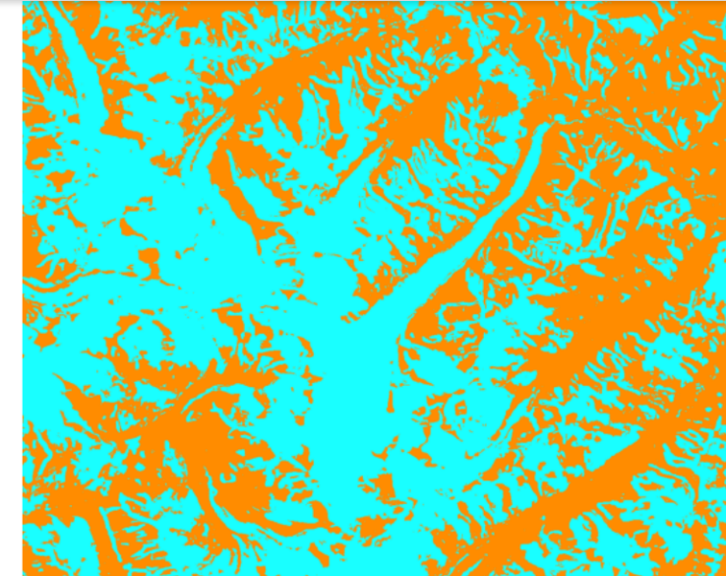
Figure 7 Random Forest Classification of the year 2020

6. Accuracy Assessment and Analysis
Table 1 classification results showing area distribution, percentage cover, and accuracy metrics for the Drang Drung and Pensilungpa glaciers of year 2020
Table 1 Accuracy Assessment of 2020
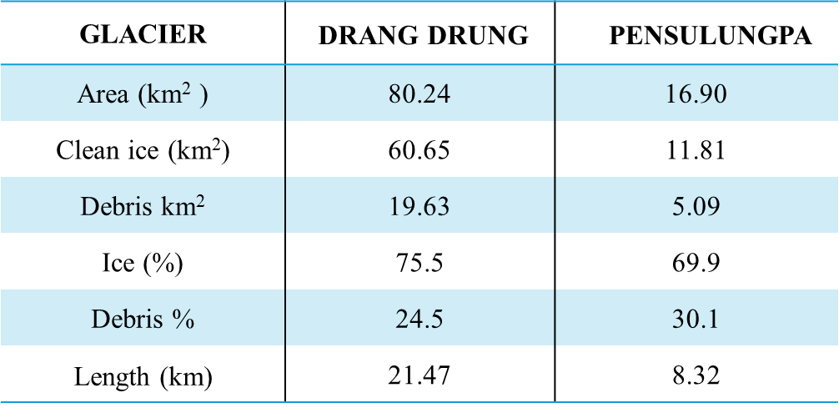

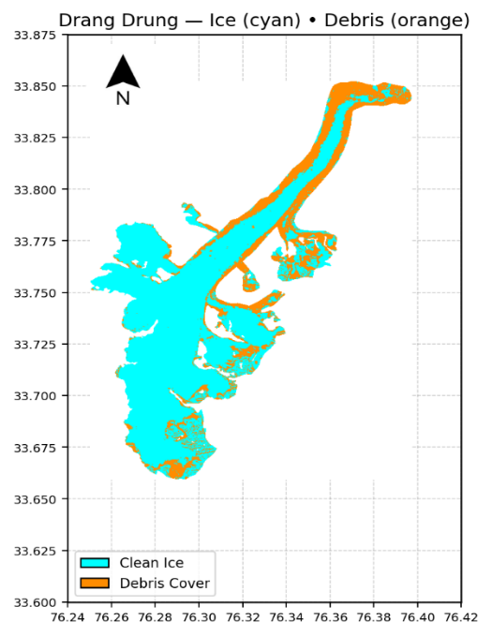
Figure 8 Debris and ice cover of Glacier Darang Durung 2020
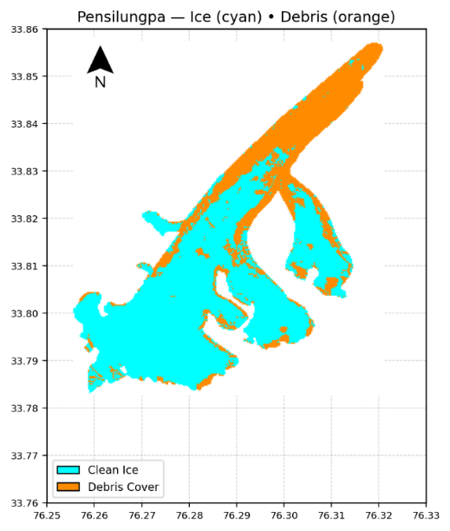
Figure 9 Debris and ice cover of Glacier Pensilungpa 2020

2.3 Result and conclusion of 2020
The classification maps for the Drang Drung and Pensilungpa glaciers (Figures 8 and 9) represent the final outputs of the multi-sensor Random Forest classification workflow described in the methodology. The workflow integrated Sentinel-1A Synthetic Aperture Radar (SAR) backscatter and textural features with Landsat-9 optical spectral bands (6, 7, and 2) to discriminate between clean ice and debris-covered glacier surfaces.

The preprocessing of Sentinel-1A SAR data involved sub-swath splitting, orbit correction, radiometric calibration, debursting, multilooking, and terrain correction using the Copernicus 30 m DEM. The use of the Improved Lee Sigma filter effectively reduced speckle noise while preserving polarimetric characteristics critical for differentiating rough debris surfaces from smooth ice. The generated C2 polarimetric covariance matrix allowed extraction of textural features such as VV backscatter strength and local variance, which were used as predictors in the Random Forest model. Concurrently, Landsat-9 imagery provided strong spectral contrast between ice and debris through the SWIR (bands 6 and 7) and Blue (band 2) bands — where ice exhibits high reflectance in the visible range and debris shows stronger absorption in SWIR wavelengths.
The Random Forest algorithm was trained using manually selected training samples derived from both datasets and validated using reference glacier outlines from GLIMS (Global Land Ice Measurements from Space). The model performed pixel-level classification to assign each cell as either clean ice or debris-covered ice, producing a high-resolution thematic map. Post-classification refinement was carried out to remove isolated noise pixels and smooth class boundaries.
In the resulting maps, cyan areas represent clean ice zones, which are characterized by low radar backscatter and high optical reflectance, indicating smooth, homogeneous glacier ice with minimal surface material. Orange regions denote debris-covered ice, where radar returns are stronger due to surface roughness and mixed dielectric properties of rock, soil, and ice.
For the Drang Drung Glacier, the classification reveals a predominant clean ice cover in the central and upper accumulation zones, while the ablation area and lateral margins show extensive debris coverage. The thick debris layer along the glacier’s tongue aligns with radar backscatter variations observed in the pre-processed Sentinel-1A data. Quantitatively, debris cover constitutes approximately 22.32 km² (27.3%) of the total 80.24 km² glacier area, while clean ice occupies 58.01 km² (72.3%). This relatively lower debris proportion suggests that much of Drang Drung remains active, though the debris-covered terminus indicates ongoing melt and ice flow deceleration.
In contrast, the Pensilungpa Glacier demonstrates a more extensive debris mantle relative to its size. The ablation zone is heavily debris-covered (orange), particularly toward the lower tongue and along the side moraines, while clean ice (cyan) dominates the upper catchment. The debris-covered area is 6.09 km² (36%) out of a total 16.89 km², ice covered is 10.89(64%) highlighting that this glacier experiences stronger rockfall and sediment deposition from adjacent valley slopes. The thicker debris layer likely acts as an insulator, reducing melt rates in some areas while promoting the development of thermokarst features elsewhere.
The classification accuracy assessment confirmed high reliability, with overall accuracies of 94.2% for Drang Drung and 90.8% for Pensilungpa, supported by Kappa coefficients of 0.9 and 0.8, respectively. The consistency between classification results and optical satellite observations validates the effectiveness of the combined radar–optical Random Forest approach.
Overall, these classification results demonstrate that Sentinel-1A SAR texture metrics and Landsat-8 spectral indices can effectively delineate glacier surface heterogeneity in the Ladakh Himalaya. The identified debris zones are critical for understanding glacier melt dynamics, surface energy balance, and potential water resource implications under changing climatic conditions.

References
Azam, M. F., Hussain, M. A., Kaushik, H., Srivastava, S., Munda, M. K., Mandal, A., Bahuguna, I., Singh, S. K., & Jawad, M. (2025). Initial glaciological investigations on a large Himalayan glacier: Drang Drung (Zanskar, Ladakh, India). Journal of Glaciology, 71. https://doi.org/10.1017/jog.2024.102
Bhattacharjee, S., Garg, R. D., & Chandra Pandey, A. (2025). Resolving changes in a Himalayan glacier (Drang Drung) using the SAR polarimetric technique. Research in Cold and Arid Regions. https://doi.org/10.1016/j.rcar.2025.08.002
Himalaya, L., Kunmar, P., Mehta, M., Kumar, V., Singh Rana, A., & Nainwal, H. (2025). Variations in meltwater discharge and morphological changes of Parkachik Glacier, Suru River Valley. In Himalayan Geology (Vol. 46, Issue 1).
Mandal, A., Vishwakarma, B. D., Angchuk, T., Azam, M. F., Garg, P. K., & Soheb, M. (2024). Glacier mass balance and its climatic and nonclimatic drivers in the Ladakh region during 2000–2021 from remote sensing data. Journal of Glaciology, 70. https://doi.org/10.1017/jog.2024.19
Mehta, M., Kumar, V., Kunmar, P., & Sain, K. (2023). Response of the Thick and Thin Debris-Covered Glaciers between 1971 and 2019 in Ladakh Himalaya, India—A Case Study from Pensilungpa and Durung-Drung Glaciers. Sustainability (Switzerland), 15(5). https://doi.org/10.3390/su15054267
Pandey, A. C., Ghosh, S., Nathawat, M. S., & Tiwari, R. K. (2012). Area Change and Thickness Variation over Pensilungpa Glacier (J&K) using Remote Sensing. Journal of the Indian Society of Remote Sensing, 40(2), 245–255. https://doi.org/10.1007/s12524-011-0134-y
Rana, A. S., Kunmar, P., Mehta, M., & Kumar, V. (2023). Glacier retreat, dynamics and bed overdeepenings of Parkachik Glacier, Ladakh Himalaya, India. Annals of Glaciology, 64(92), 254–267. https://doi.org/10.1017/aog.2023.50
Soheb, M., Ramanathan, A., Bhardwaj, A., Coleman, M., Rea, B. R., Spagnolo, M., Singh, S., & Sam, L. (2022). Multitemporal glacier inventory revealing four decades of glacier changes in the Ladakh region. Earth System Science Data, 14(9), 4171–4185. https://doi.org/10.5194/essd-14-4171-2022

